question1  
===================

To solve the problem of counting inversions in an array efficiently, we can use a modified version of the merge sort algorithm. The brute-force approach, which involves checking every pair of indices (P, Q), would take O(N2), which is inefficient for large arrays. The merge sort approach, however, allows us to count inversions in O(Nlog⁡N) time.

Approach:

Merge Sort:

This algorithm recursively splits the array into two halves, sorts each half, and then merges them back together. During the merge step, we can count inversions:

If an element from the right half is placed before an element from the left half, then all remaining elements in the left half form inversions with this element.

Early Exit:

If the count of inversions exceeds 1,000,000,000 at any point during the merge process, we can return -1 immediately.

Solution is specified in question1 folder

<https://github.com/basantbhandari/treeleaf-python-developer/tree/main/question1>

question2  
===================

Setup the kafka in window 11 (not exact names but quite similar concept):

Reference :

<https://www.youtube.com/watch?v=7SEDqTc1sTE>

<https://github.com/apostolos1927/kafkademo/blob/main/cmd%20commands.txt>

goto "C:\kafka" dir  
start zookeeper as "PS C:\kafka> .\bin\windows\zookeeper-server-start.bat .\config\zookeeper.properties"  
start kafka server as "PS C:\kafka> .\bin\windows\kafka-server-start.bat .\config\server.properties"

Should look like following screenshot

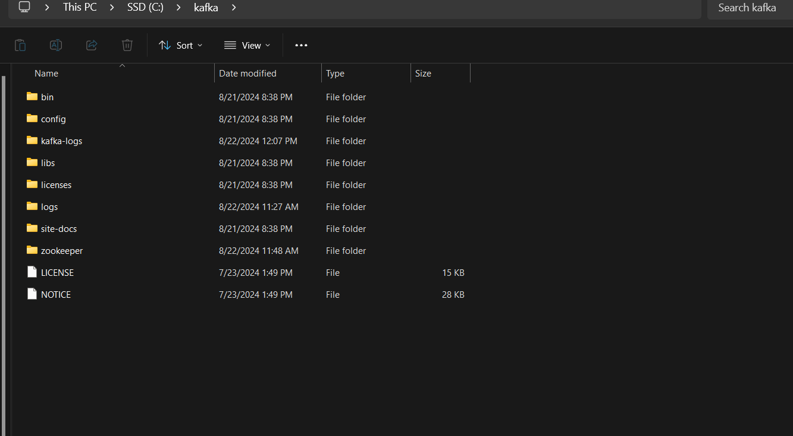

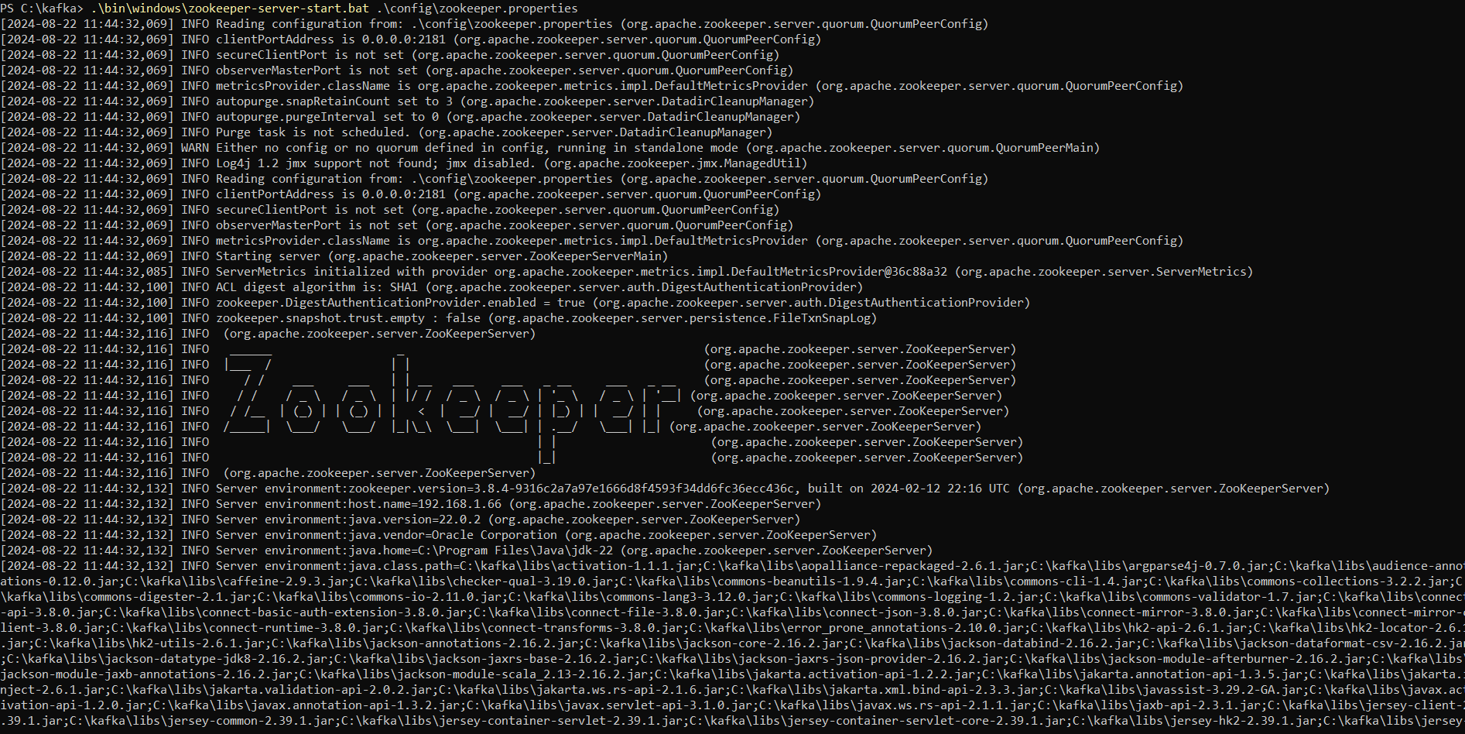  
  
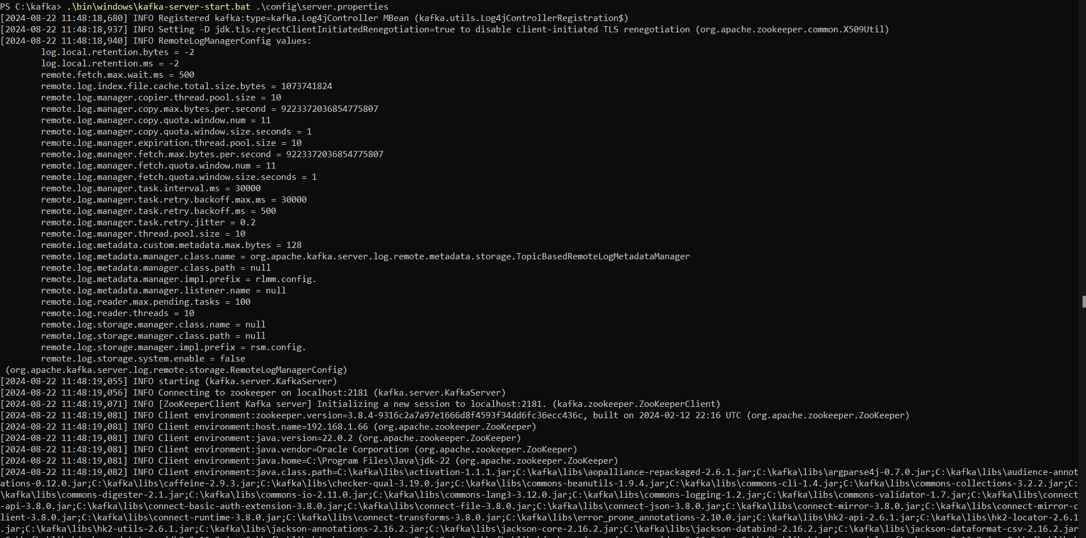

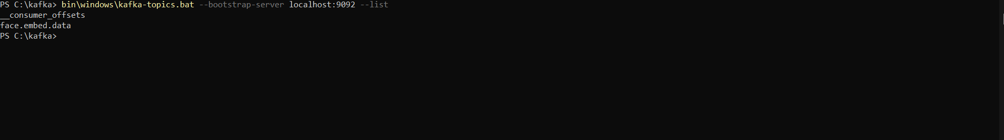

Once the kafka server is running in the on the local

Start a django rest project named “demo” and create app called “kafka_app” and you can see the source code in question2 folder.

<https://github.com/basantbhandari/treeleaf-python-developer/tree/main/question2>

Start the rest api server

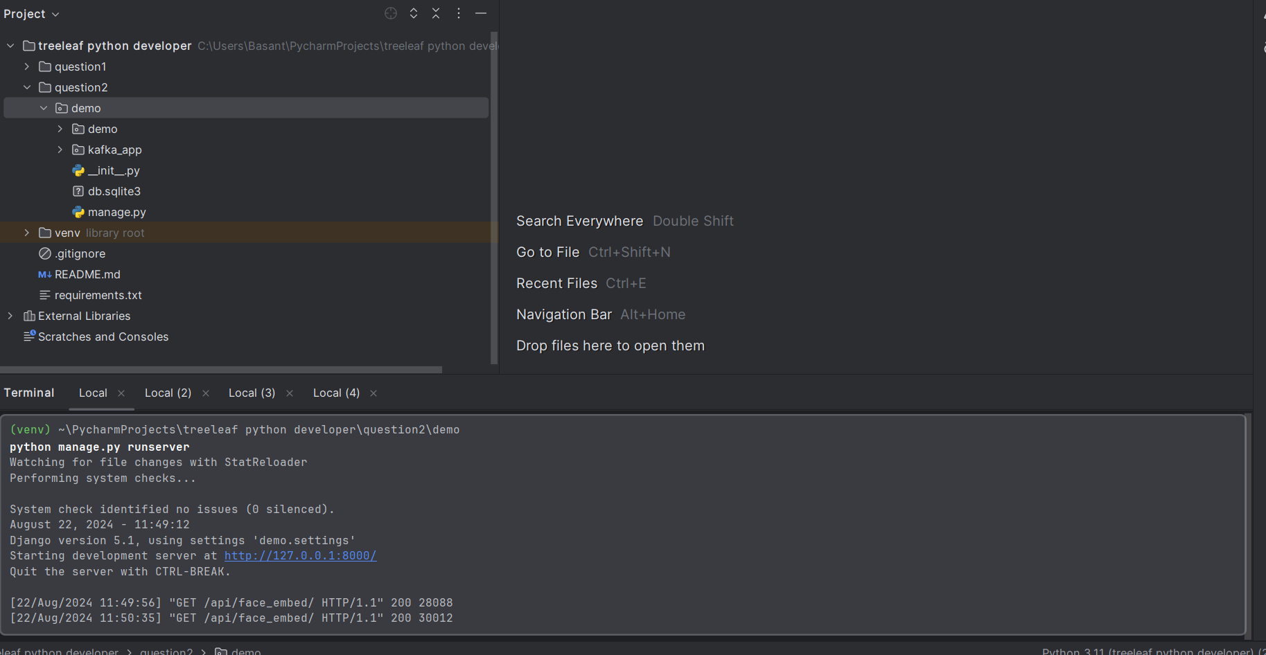

To run the kafka producer

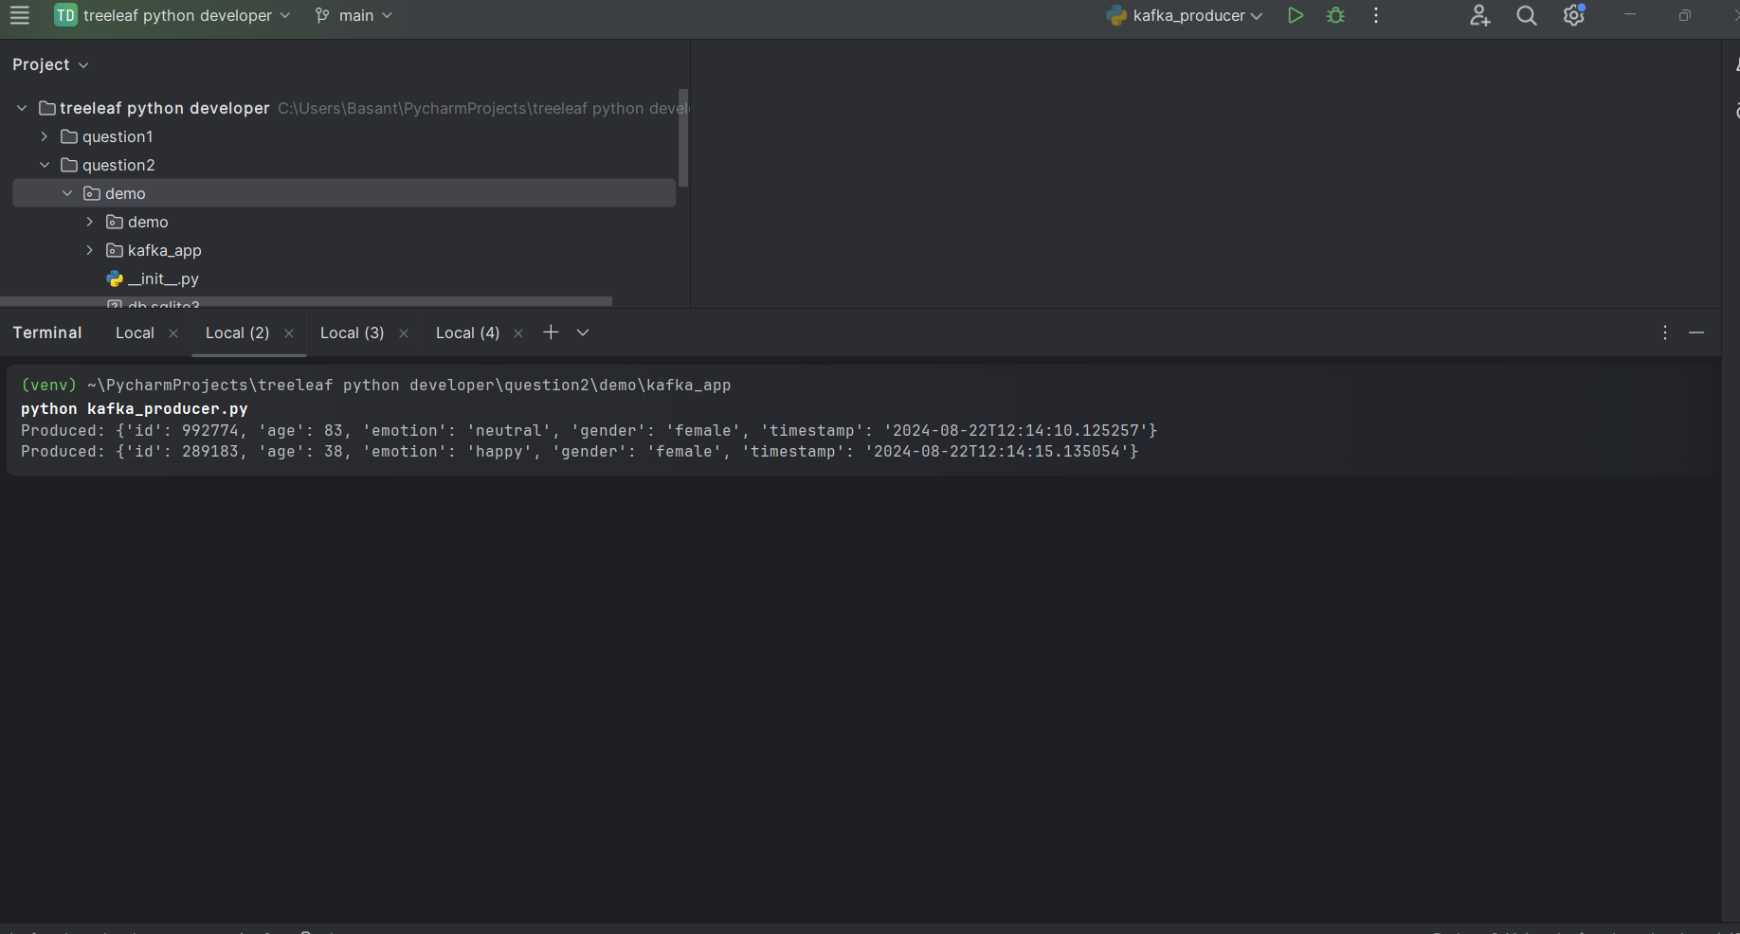

To run the kafka consumer that store the consumed data into django model named “FaceEmbed”

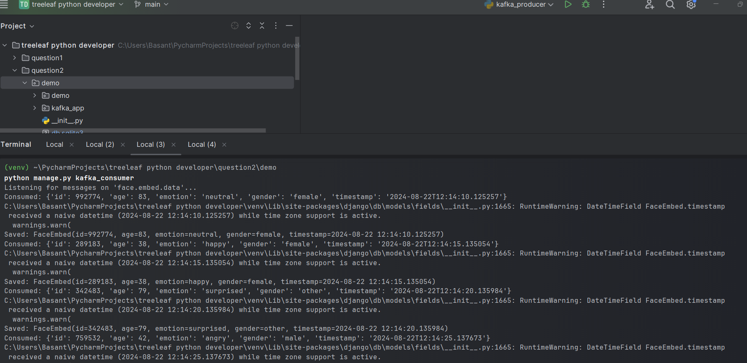

You can see all the data stored in model consumed by kafka consumer using rest api end point <http://127.0.0.1:8000/api/face_embed/>

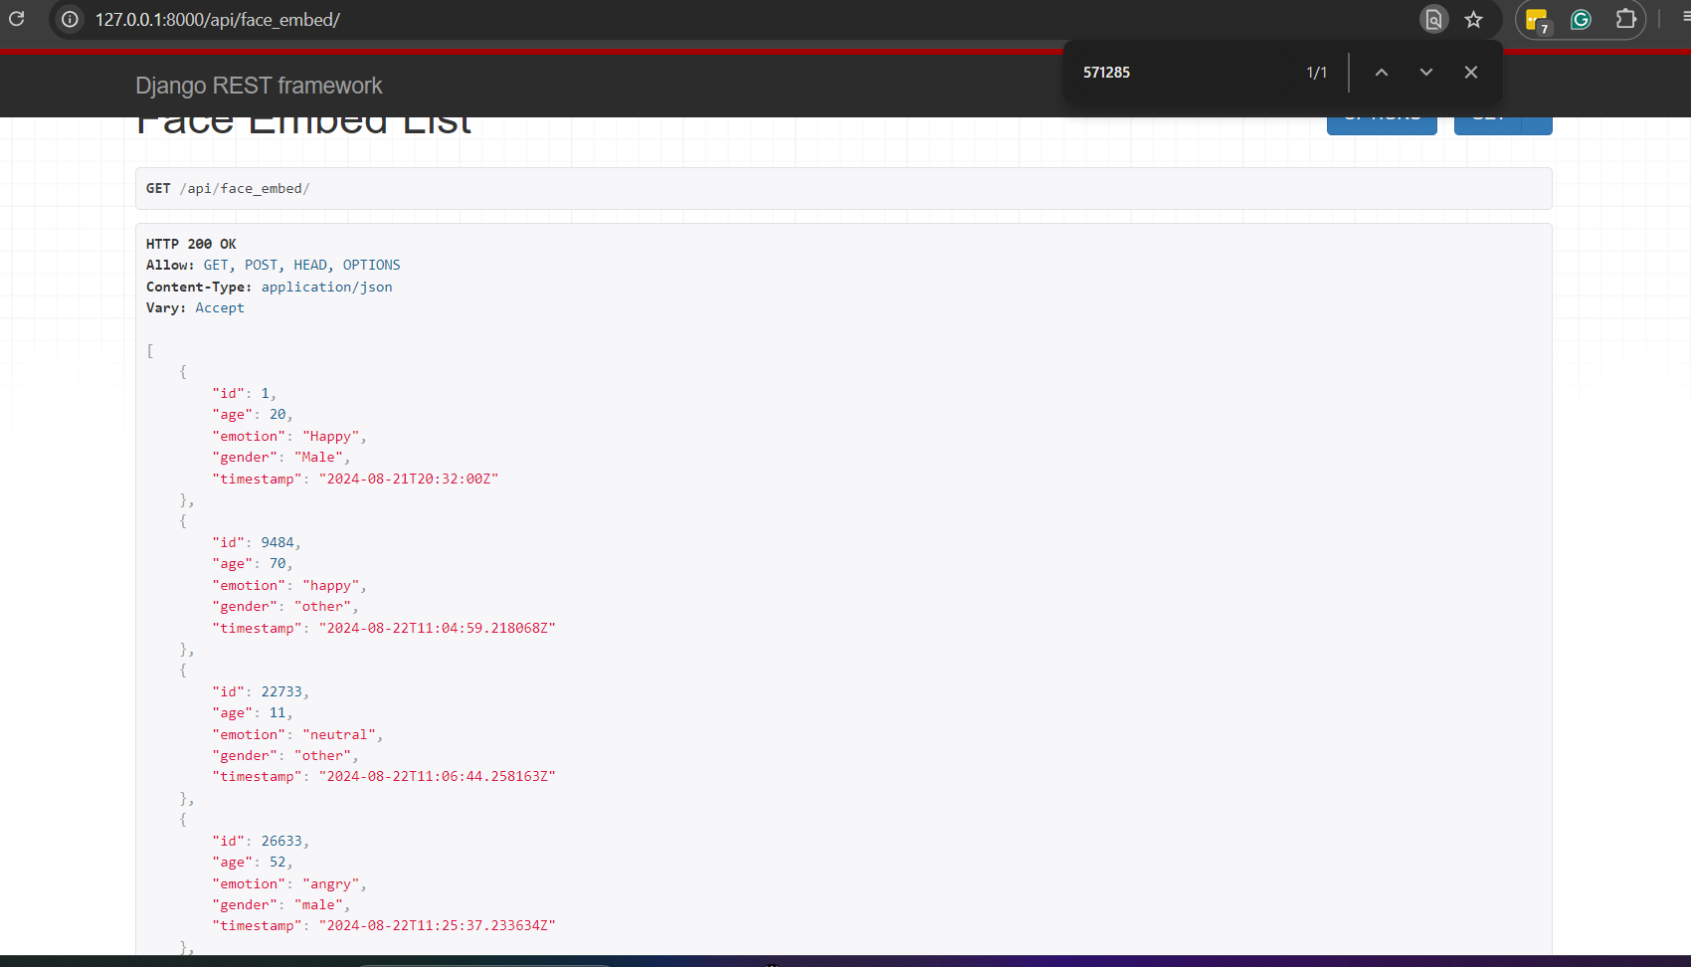

I think this meets the requirements.

I have created dependency file: <https://github.com/basantbhandari/treeleaf-python-developer/blob/main/requirements.txt>

Make sure to turn off the firewall setting if you faced any issue wile connecting Django server with Kafka server

